Dear Parents/Guardians:
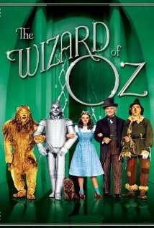
Our students in grades 1 through 8 will be attending the Friday, December 19th performance of The Wizard of Oz at the Scotiabank Convention Centre on Stanley Ave. at 9:45am.
We are very excited that this fully professional performance will be presented by the same group that has produced: Annie, Peter Pan, Beauty and the Beast, Aladdin, and Oliver!

Students will be leaving by bus at 8:55am, and will be returning to the school by 12:30pm. The performance time is 9:45am – 11:45pm.

We are very fortunate to offer the trip at a discounted price of $15.00 per student/chaperone. This includes the cost of the ticket plus the cost of transportation to and from the Convention Centre.
Parents are welcome to attend but should be prepared to provide their own transportation to and from the Convention Centre.

Please return this signed permission form, with payment, to the school no later than Friday, December 12th, 2014.

Regards,
Ross Staff
___________________________________________________________________

I give permission for my son/daughter,_________________________, to
attend The Wizard of Oz on Friday, December 19th.

____ I have enclosed $15.00 for the trip.

____ I am interested in being a parent chaperone on this field trip.
(Please circle) YES NO

I would like to purchase ________ tickets x $15.00 for additional adults. Transportation will not be provided for additional ticket holders.

